**Front Door Load Balancer**

**Note1:** In order to make the unsecure (HTTP) application into secure (HTTPS) application

[Switch from HTTP to HTTPS] we have to install some secure certificates like SSL and TLS certificates. And these certificates should be purchased from trusted Certificate Authority (CA) like Let's Encrypt (free) or a commercial provider. So that our unsecure website turns into secure website.

Note2: SSL/TLS certificates can have various file extensions, depending on the format:

* **.crt**
  + Often used for certificates in **PEM (Privacy Enhanced Mail)** format.
  + PEM files are text-based and commonly used for exchanging certificates.
* **.cer**
  + Another common extension for certificates, often used for **DER (Distinguished Encoding Rules)** format.
  + DER is a binary format.
* **.pem**
  + Specifically indicates a file in **PEM format**.
* **.key**
  + Typically used for the **private key** associated with the certificate.
* **.pfx** or **.p12**
  + Represent certificates in **PKCS#12** format.
  + This format can bundle the certificate, the private key, and intermediate certificates into a single file, often password-protected.

Let’s Discourse now about Front Door Load Balancer.

**Azure Front Door** is a powerful cloud-based service that acts as a global entry point for your web applications, APIs, and content.

It is same as Application Gate way but the different is it support globally and CDN (content delivery network).

**Front Door Features:**

1. It works on URL/path based routing.
2. It works on layer-7 of OSI model (application layer).
3. It supports HTTP & HTTPS based applications.
4. It supports WAF (Web Application Firewall).
5. It supports multiple Backend pools (endpoints).
6. It is a global Load balancer, because it supports only globally.
7. It supports CND (content delivery network).

**Note:** **Content Delivery Network (CDN) Capabilities:** Caches content at the edge servers, delivering it faster to users around the world. Instead of caching it from original servers. (CDN providers like Adigo, Akama, micro soft, AWS cloud front and so on…)

**Note: Cookies:** Cookies are small text files that websites store on your device (computer, phone, and tablet).

Cookies help websites remember that you're logged in, so you don't have to enter your username and password each time.

**Configuration:**

* Frontend domain name
* Backend Pool
* Routing Rules.

**Let’s Create the Front Door Load Balancer:**

**Step1**: create two Virtual machines (east-VM & west-VM) in two different regions and resource group (east-rg & west-rg).

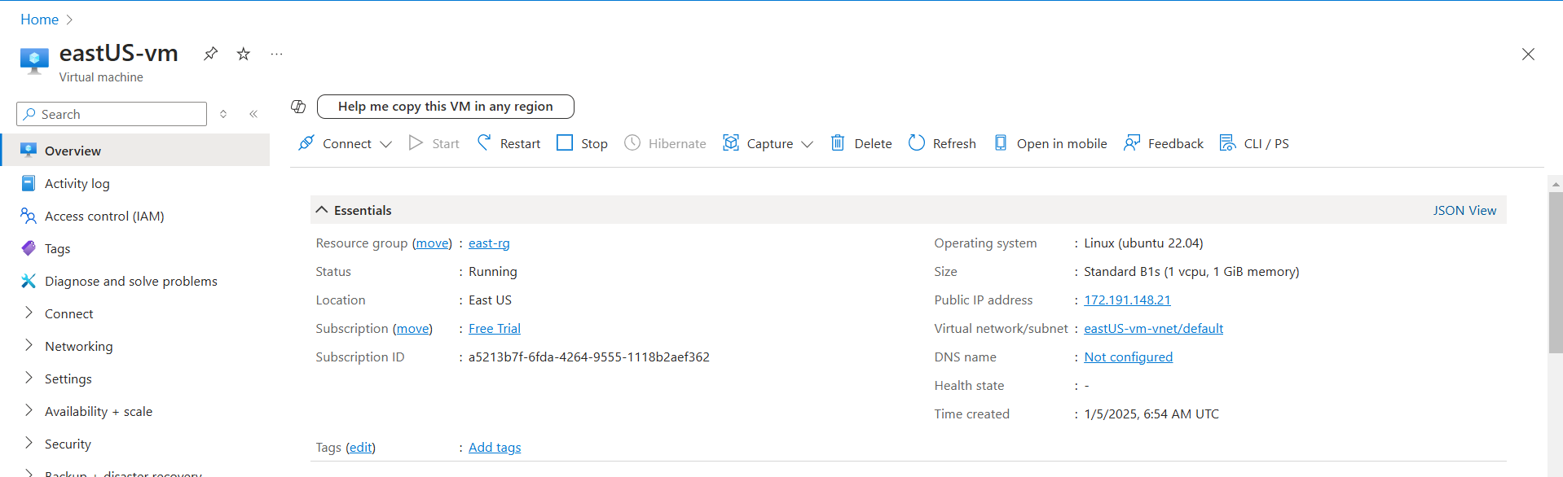

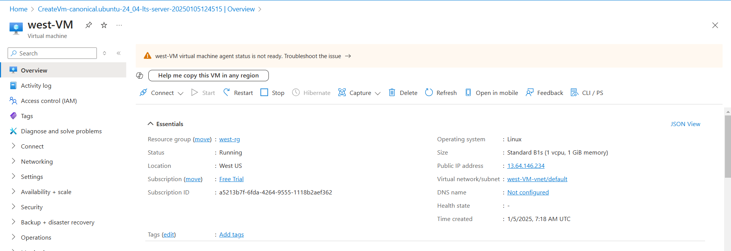

**Step2:** Create the Front Door Load Balancer by configuring the frontend domain, Backend pool and Routing rules.

**Note :** we can create the Front Door LB in separate or with the VM resource groups (est-rg & west-rg).

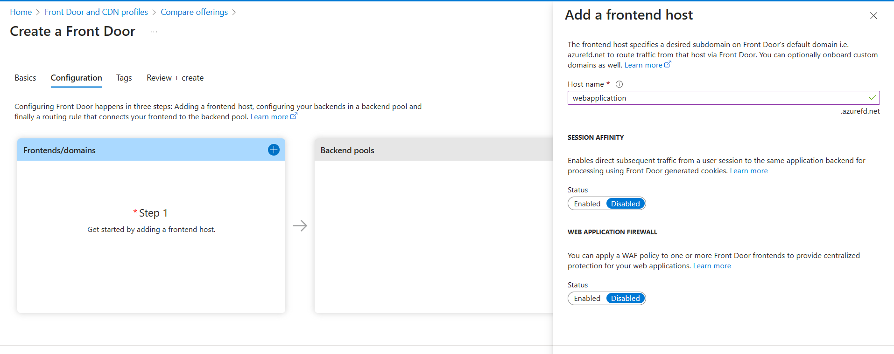 Case1: configure frontend domain.

Case2: configure the Backend pools.

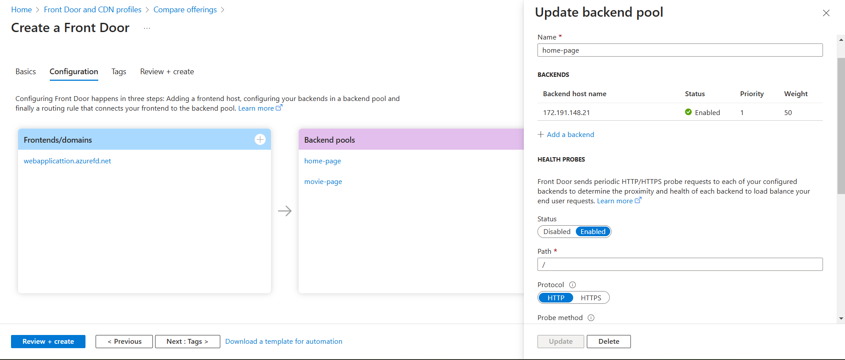

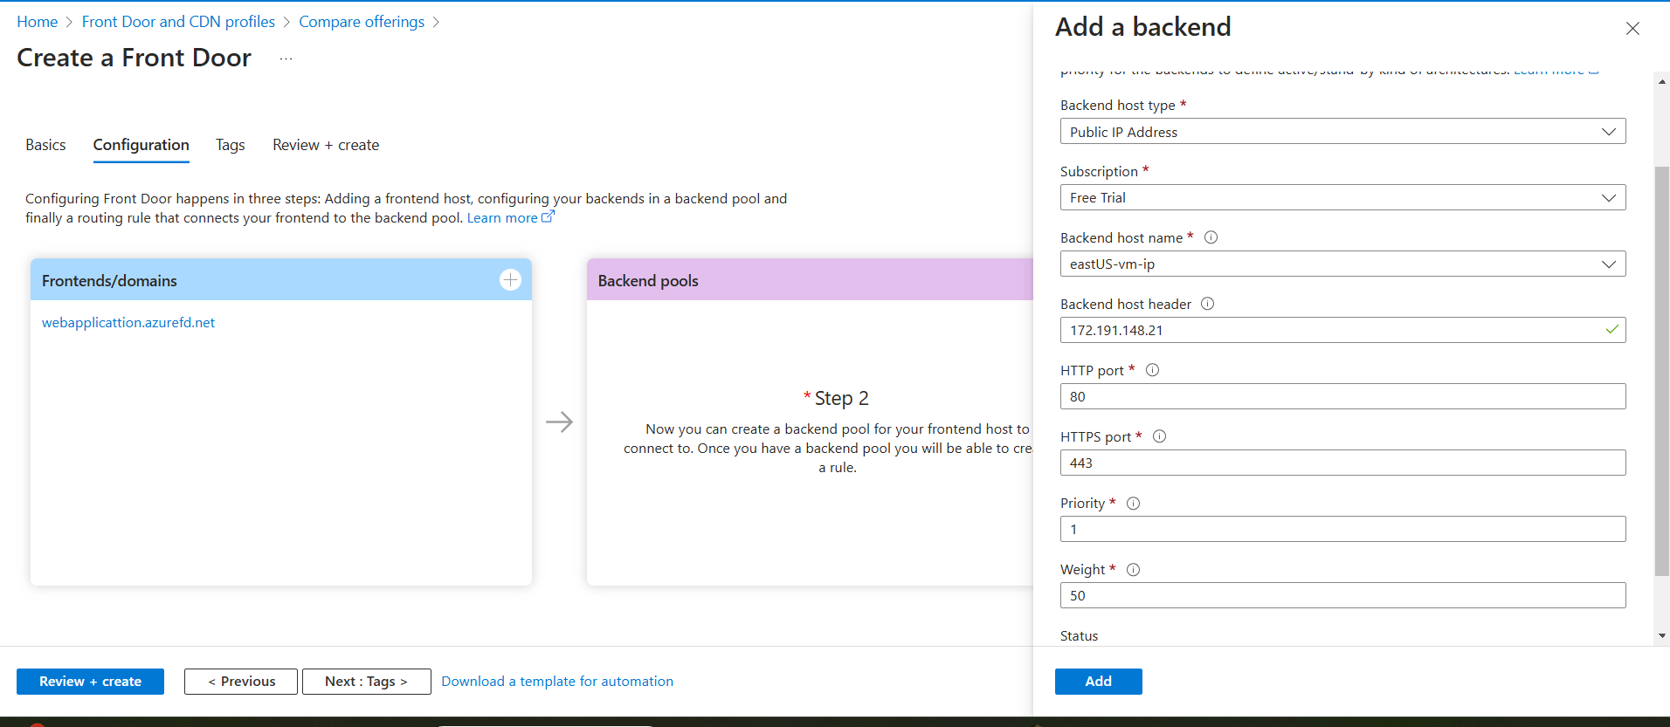

**Fig**: Add east-US VM IP as Backend pool with default path “/”.

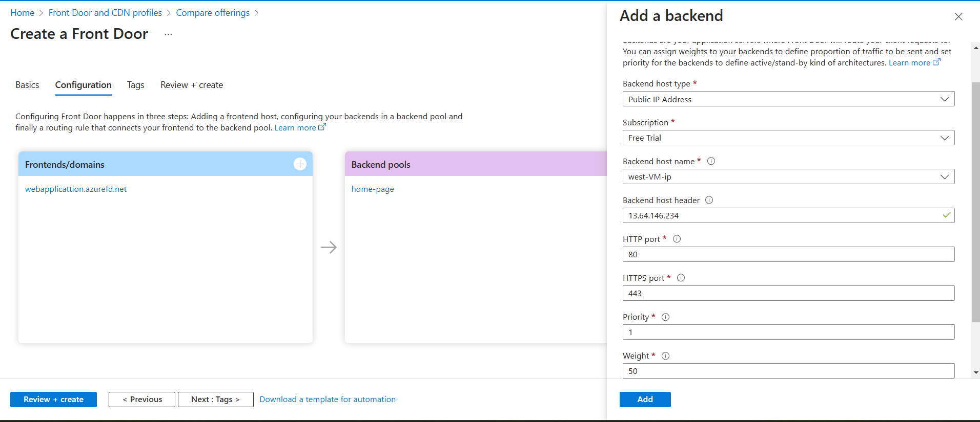Add the Movies-VM to the backend pool:

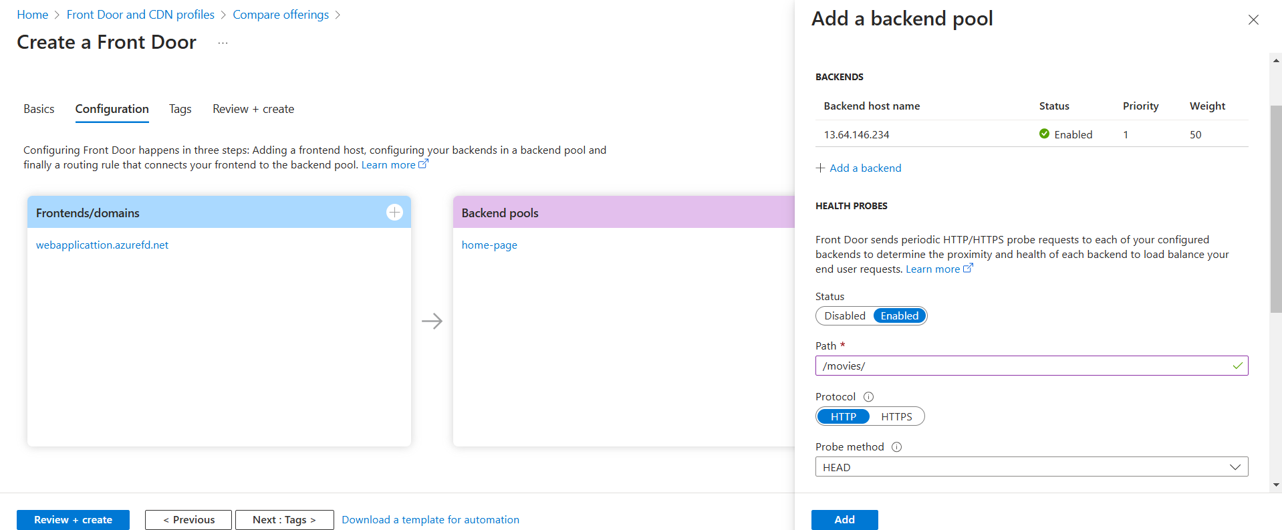

Fig: Add west-us VM IP to the Backend pool with path “/movies/”.

Case3: Add the Routing Rules.

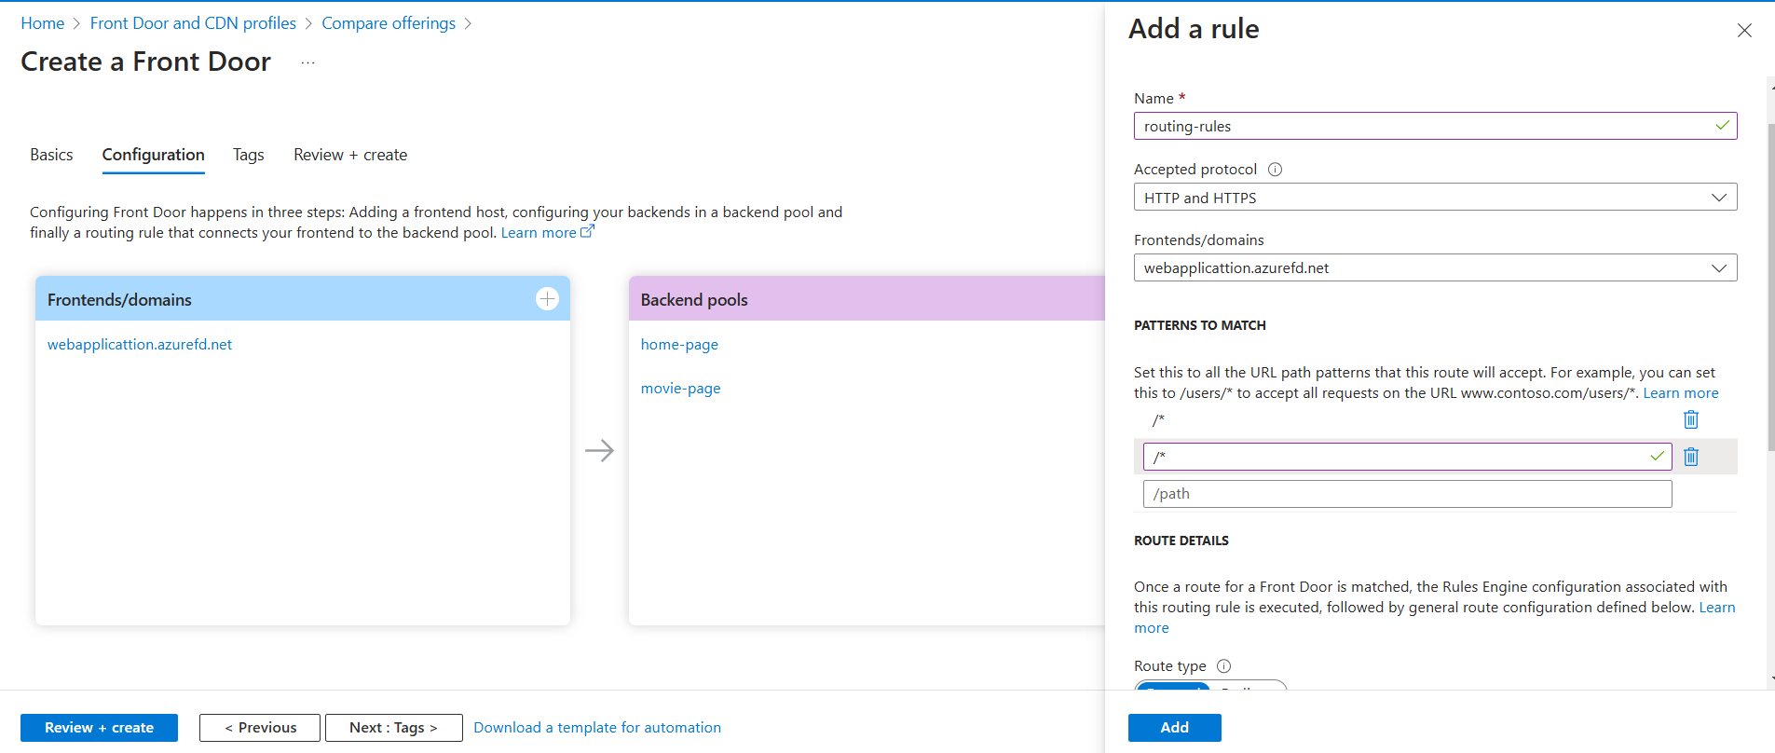

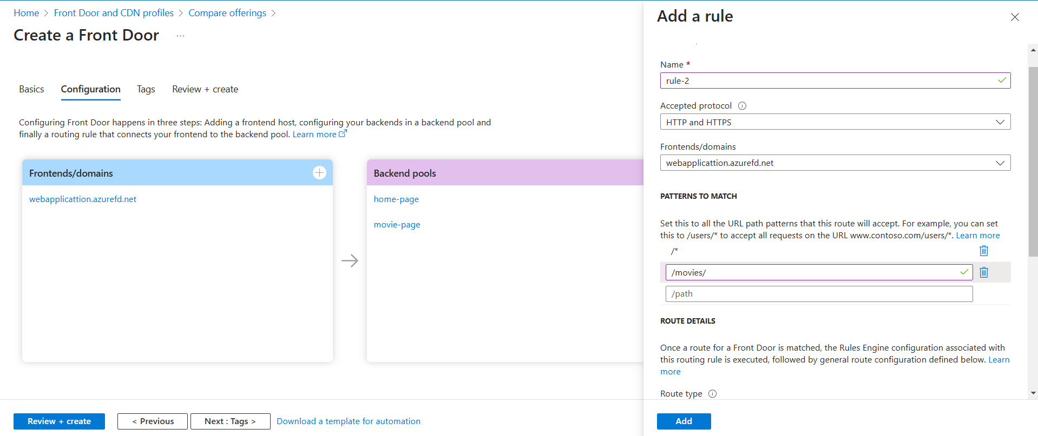Fig: Adding rule-1

Fig: Adding rule-2

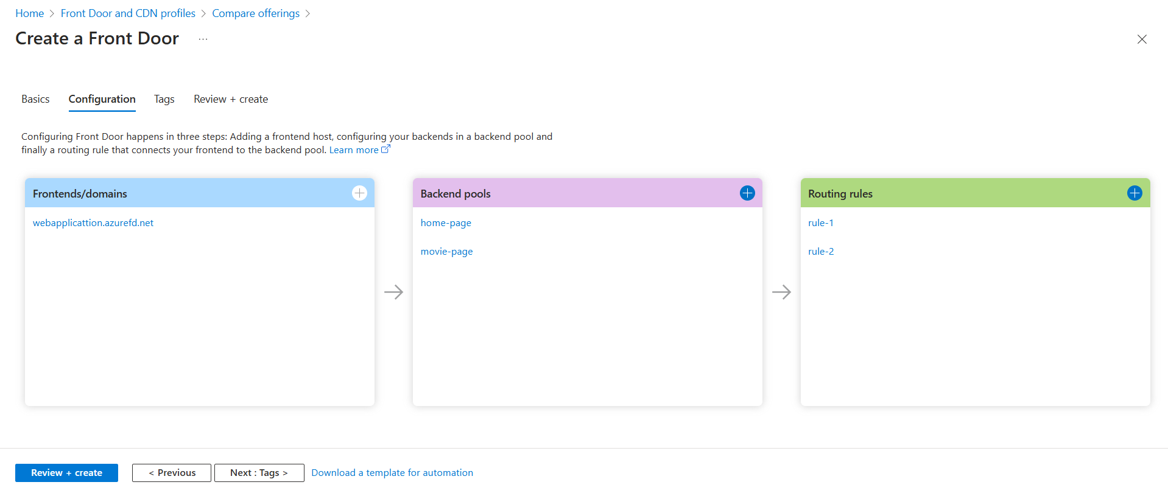

Now click on review+create option then our Front Door Load Balancer will be created.

Now by using the frontend domain (webapplication.azurefd.net) brows in any browser it will display our website based on the routing rules.

**Note:** In free trial or student account we cannot create the Front Door Load Balancer. Because **Front Door** is a premium service in Azure.

**Block Diagram of above task:**

West-rg

East-rg

West-US-VM

East-US-VM

Movies-page

Home-page

Front Door LB

FD domain name: Webapplication.azurefd.net